**VirtualBox**

*VirtualBox* is a free software tool that lets you load so called *virtual machines* on your computer. A virtual machine like a small pre-configured operating system that you can simply run in a window on your desktop computer or laptop. For example, if you have windows installed on your computer and a virtual machine with linux installed on it you can run this linux on your windows computer in a window just like your internet browser or any other app.

Download VirtualBox (Windows and Mac)

To download VirtualBox go to <http://www.virtualbox.org> and click on the “Downloads” link on the left side of the screen.

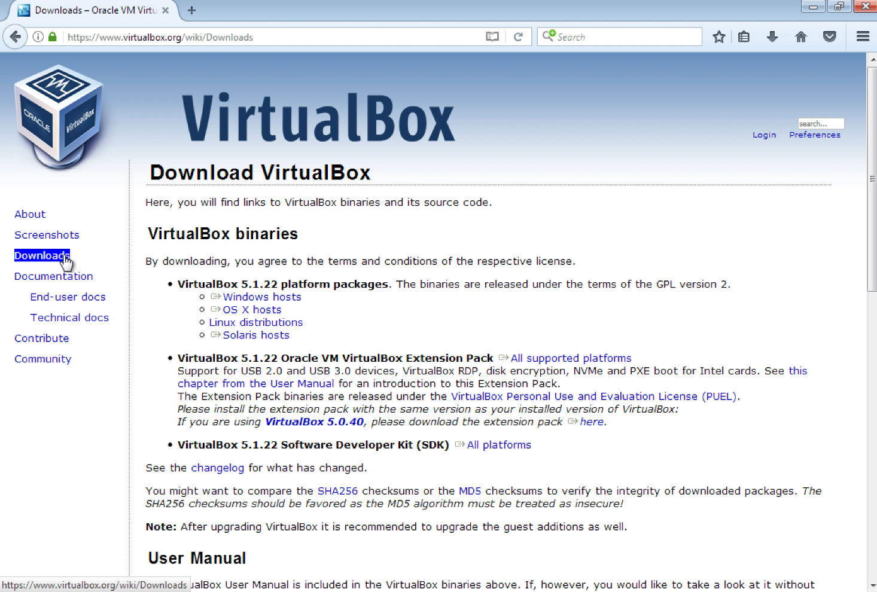

For Windows computers click on the “*Windows hosts*” link under the bald “**VirtualBox 5.211 platforms packages**”. For MacBooks or other Apple computers select the “*OS X hosts*” link.

Save the installer in a location of your choice.

Note: Some browsers automatically save downloaded files in the “Downloads” directory!

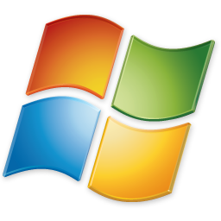

Install *VirtualBox* on Microsoft Windows computers

After the download is finished go to the location where you saved the file, double click the installer and run the installation process.

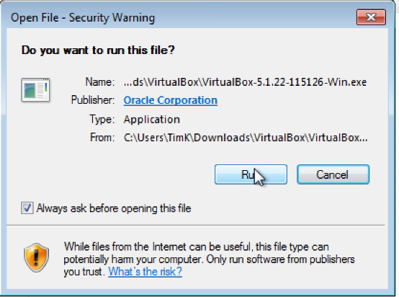

Follow the installation wizard and leave all the different default settings as they are, i.e., click *next*, *accept*, *yes* or *finish*.

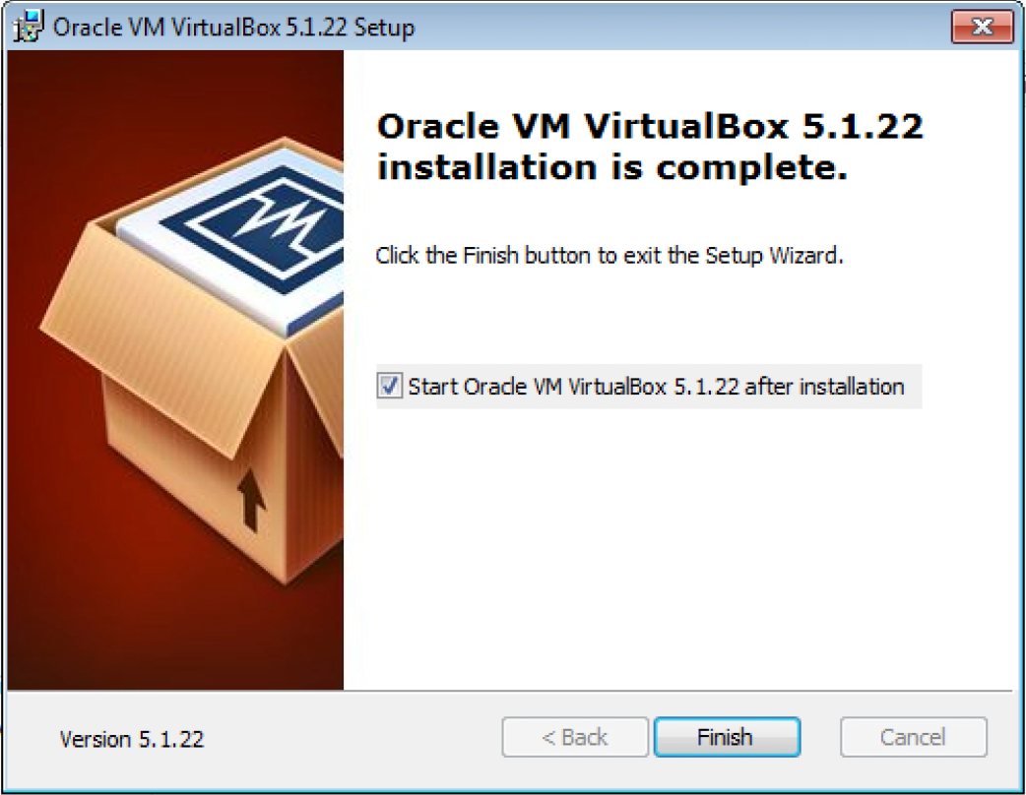



Congratulations, you just installed VirtualBox. To start the software double click the

icon on your desktop.



Install *VirtualBox* on Mac OS X

After the download is finished go to the location where you saved the *dmg* file and double click it. In the pop-up window couble click the yellow *VirtualBox.pkg* icon.

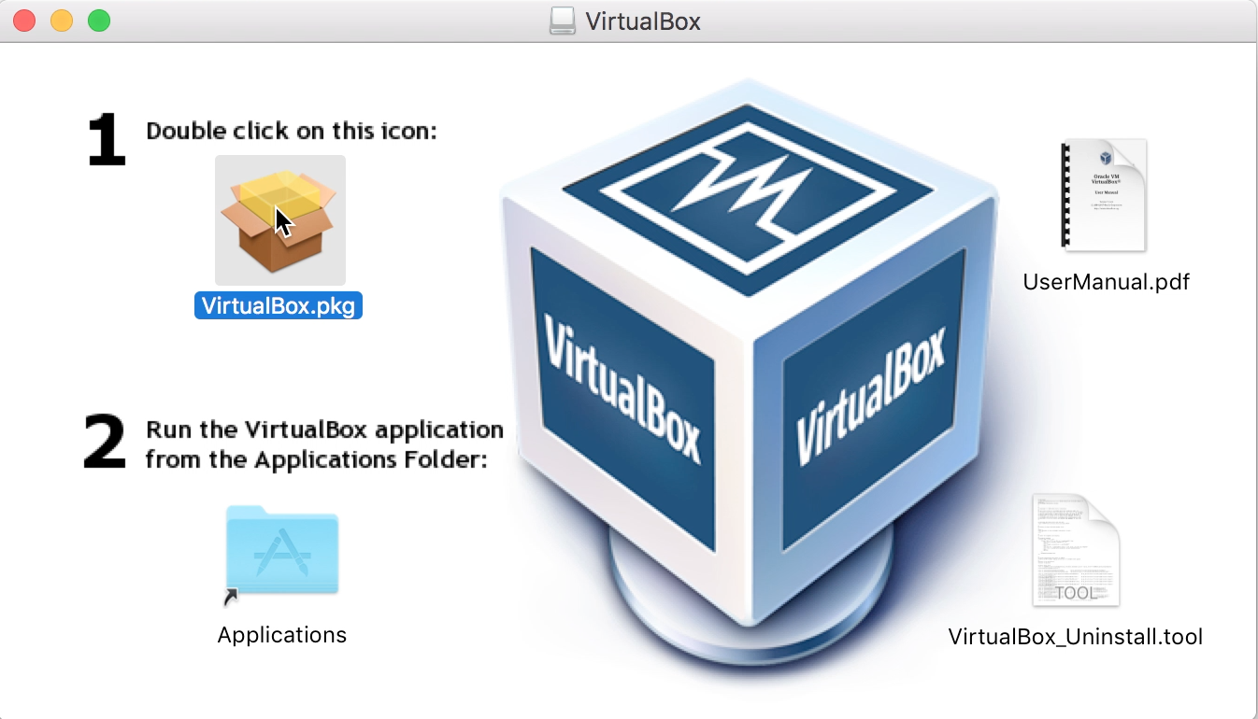

After clicking the installation process will start and several dialog windows will appear.

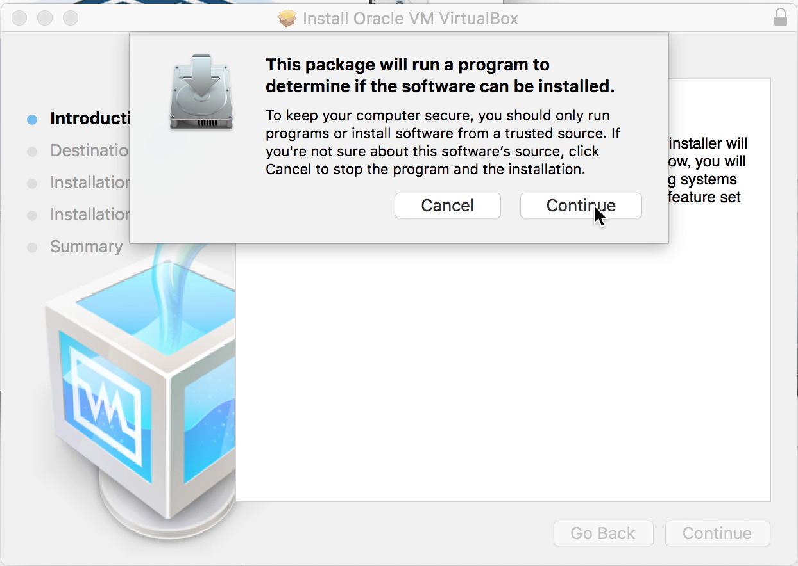 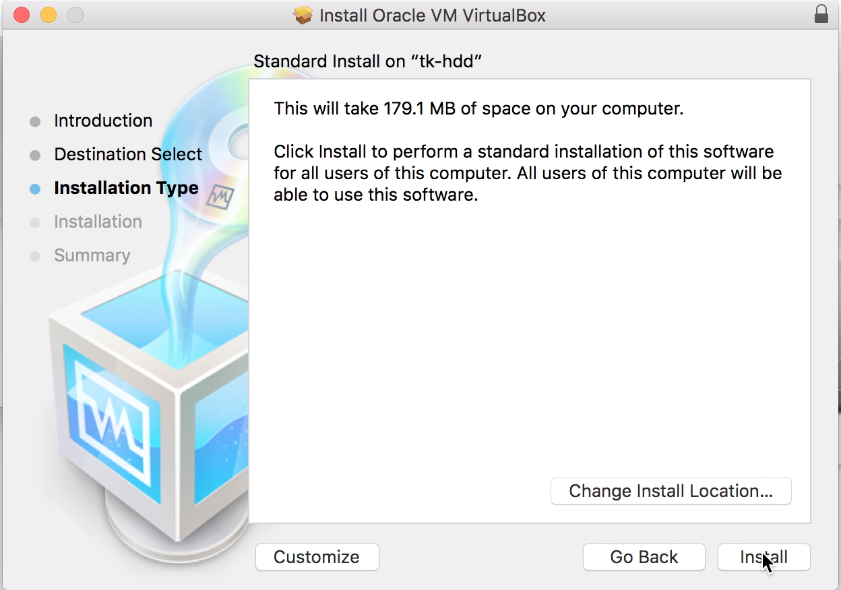

Follow the instructions and continue the installation process until it is finished. You might have to type in your administrator password at one point to finish the installation.

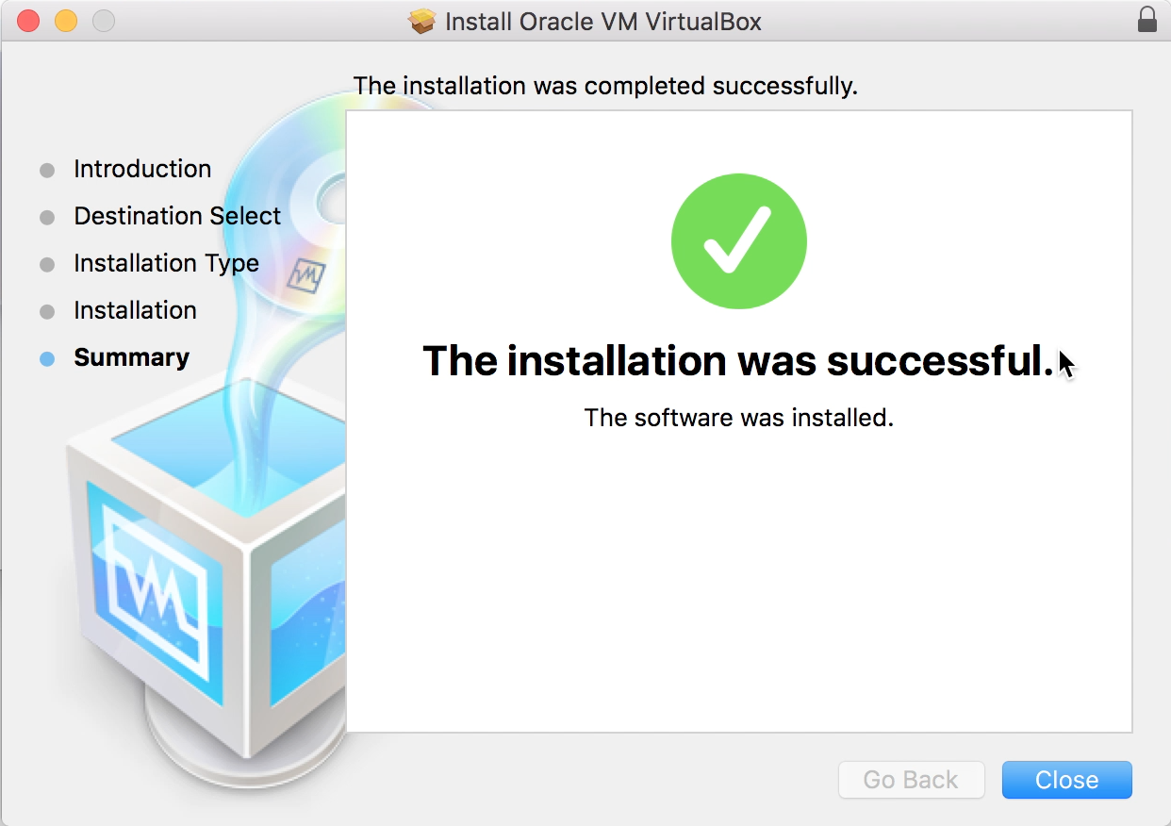

Congratulations, you just installed VirtualBox. To start the software double click the *VirtualBox.app* in your *Applications* folder.